DISTAF
Digital Identity Systems
Trustworthiness Assessment
Framework

User Manual

Version 1.0

Acknowledgements.
This work was supported, in whole or in part, by the Bill & Melinda Gates Foundation [INV-001309]. Under the grant conditions of the Foundation, a Creative Commons Attribution 4.0 Generic License has already been assigned to the Author’s Accepted Manuscript.
The Institute is named in honour of Alan Turing, whose pioneering work in theoretical and applied mathematics, engineering and computing is considered to have laid the foundations for modern-day data science and artificial intelligence. It was established in 2015 by five founding universities and became the United Kingdom’s (UK) National Institute for Data Science and Artificial Intelligence. Today, Turing brings together academics from 13 of the UK’s leading universities and hosts visiting fellows and researchers from many international centres of academic excellence. Turing also liaises with public bodies and is supported by collaborations with influential organisations.

Contents
1. Log-in and Log-out 4
2. How to change own password 5
3. Creating a new user and assigning roles 6
4. Resetting a user password 8
5. Creating, searching and viewing an assessment 10
6. Editing an assessment 10
7. Creating an assessment report 14
8. Creating a comparison report 14
9. Colour legend 15

Log-in and Log-out
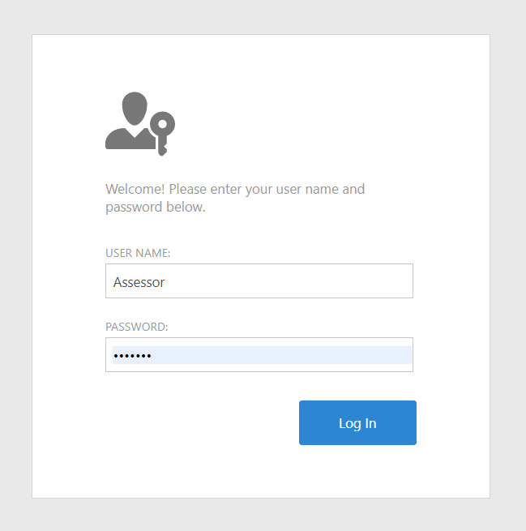
The login process is a mandatory step to verify the identity of a user attempting to access the system. It involves the following steps:
- Connect to the site at URL:

trustworthiness-framework-webapp.azurewebsites.net

- Enter your username and password.
- Press the Log In button.

Symmetrically, the log-out process is used to close the current session, as follows:
- On the top right page select the My Account icon
- Select the Log Off item from the drop-down menu.
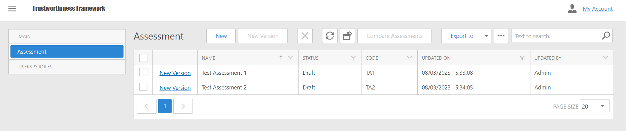



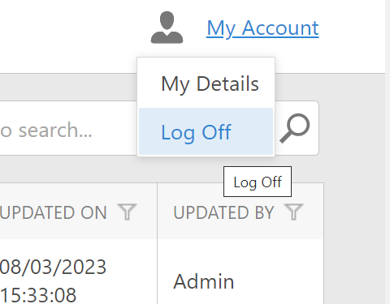

How to change own password
Every user has the possibility of changing its own password, with the following steps:
- On the top right page select the My Account icon
- Select the My Details item from the drop-down menu.

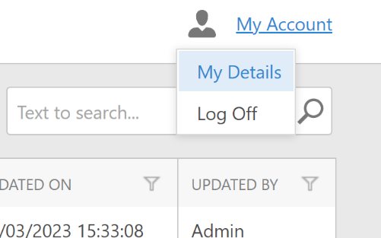
- Select the keys icon at the top right to access the Change Password page.

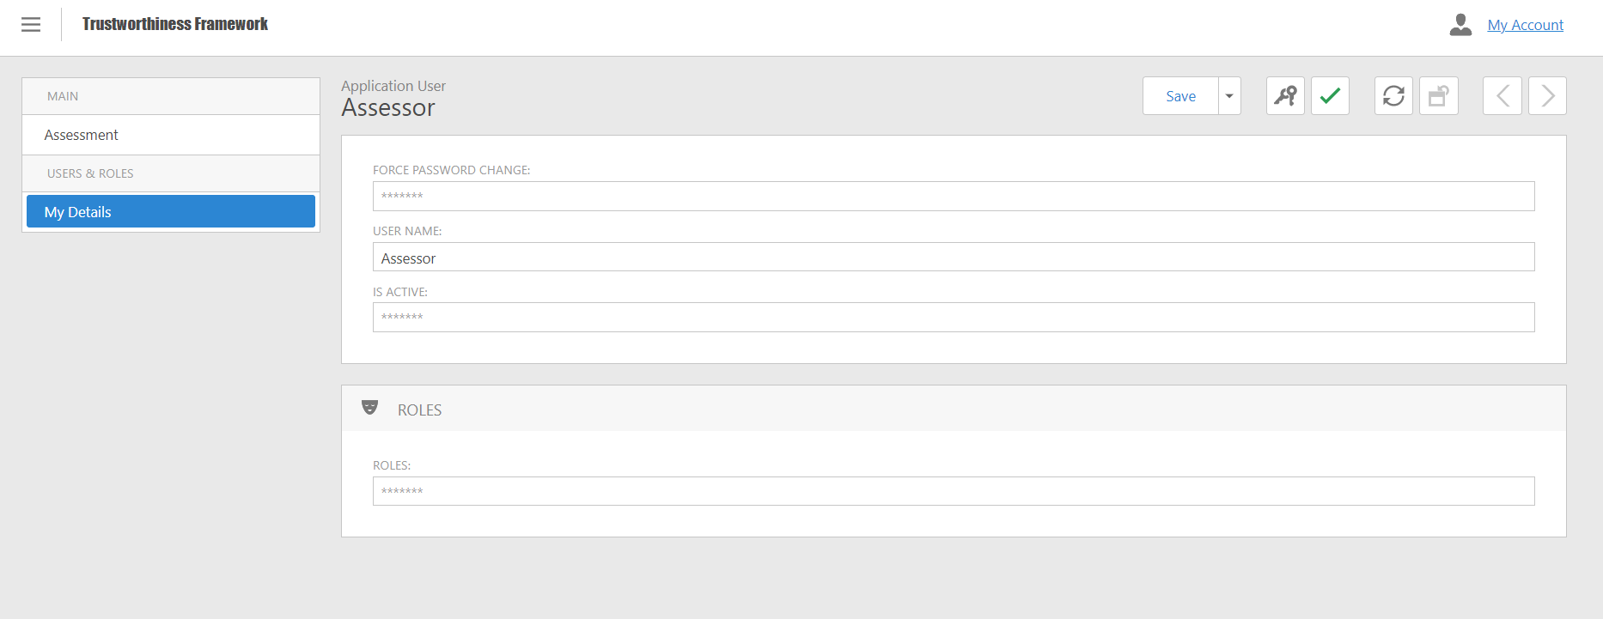
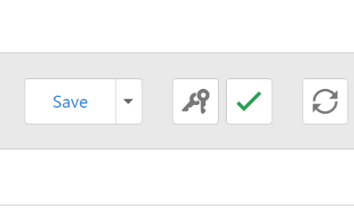

Once inside the Change Password dialog:
- Type the old password in the appropriate field.
- Enter the new password in the appropriate field.
- Repeat the new password in the appropriate field.
- Select the Ok button at the top right to confirm the change.
- Select the Cancel button to undo the change and return to the My Details page.
Confirm
the change
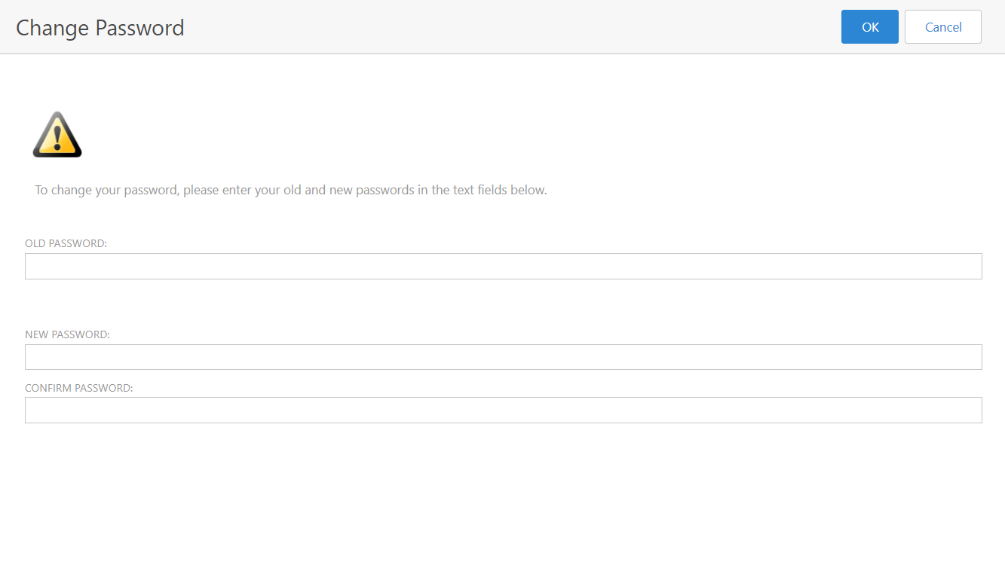
Undo
the change
New
Password
Old
Password

Creating a new user and assigning roles
When logged-in as an administrator, it is possible to create a new user and to assign the corresponding permission (roles):
- Select Application User from the menu on the left in the User and Roles section.
- Select the New button at the top right.
- Enter the name of the new user in the space provided.
- Make sure the Is Active box is checked.
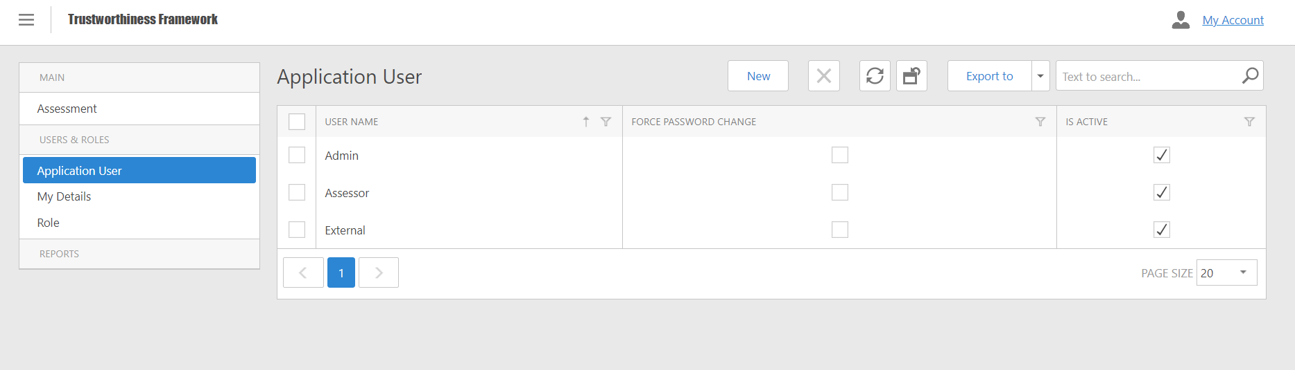

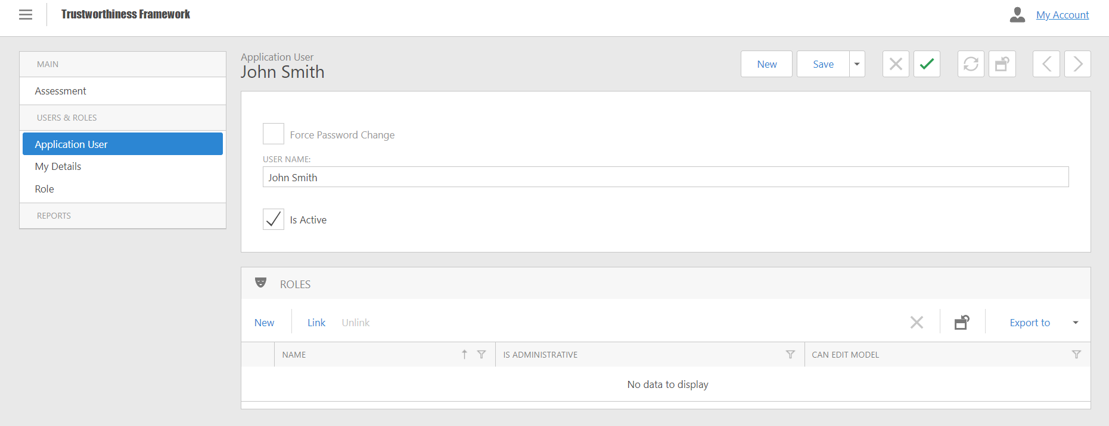
Now it is possible to assign roles, following the steps:
- Click on the Link item in the Roles box below.
- Select the role you want to assign to the user.

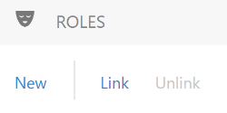
- Select the blue "Ok" button at the bottom right to confirm the operation.
- In the "Role" pane you can now view the role assigned to the new user.
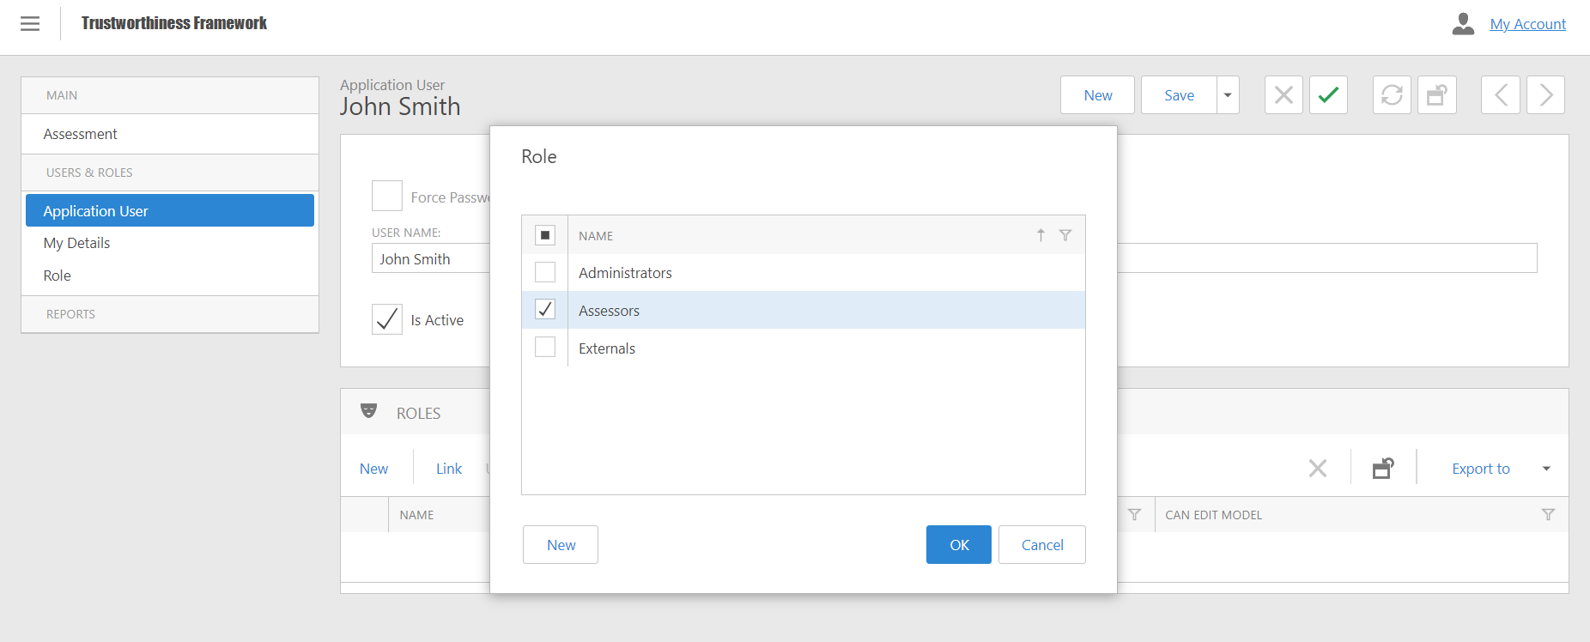
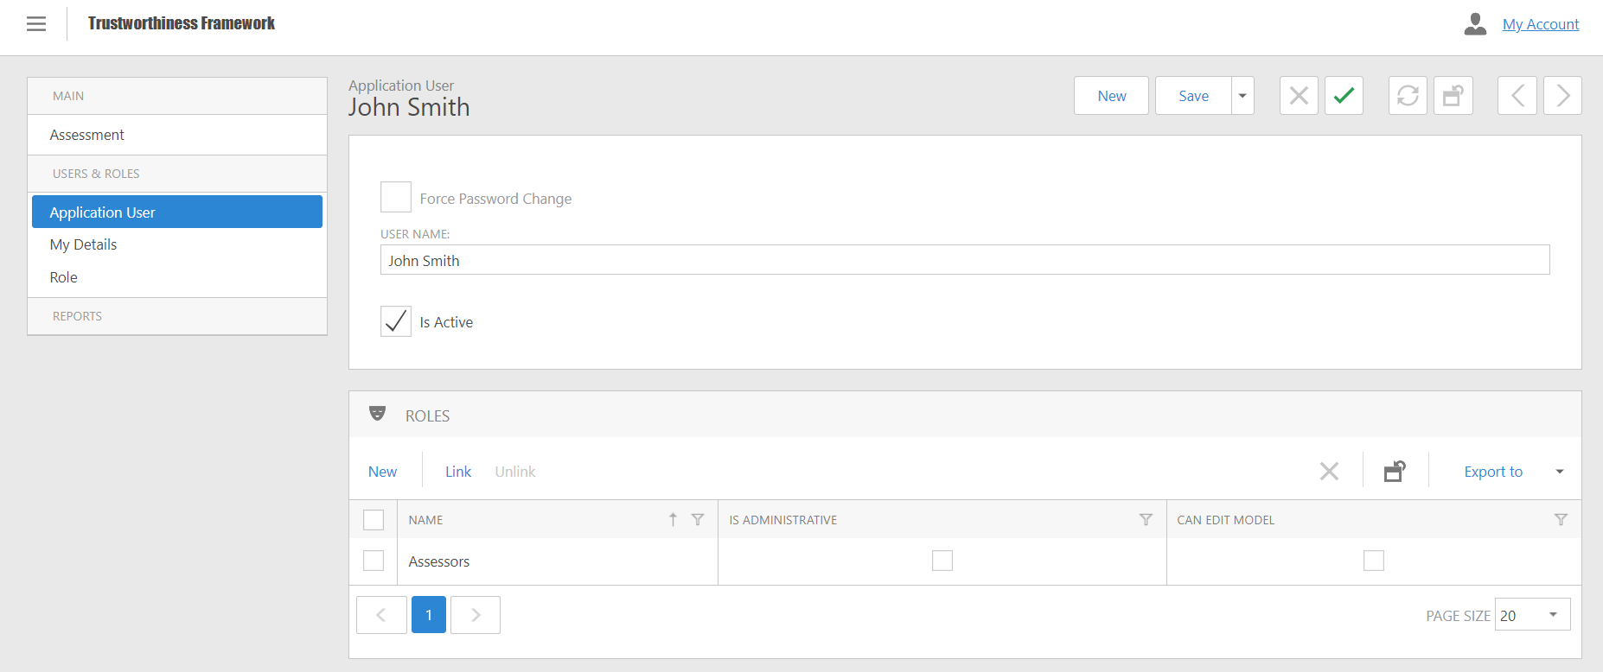
- Press the "Save" button at the top right to save the changes.

Resetting a user password
In case a user forgot their own password, it is possible to reset it with the following steps:
- In the menu on the left select the page "Application User"
- Check the relevant username.
- Click on the user's name to open his page.
- Click on the “key” symbol from the menu at the top right.
- The system will automatically generate the new password that the user will have to insert at the next access.
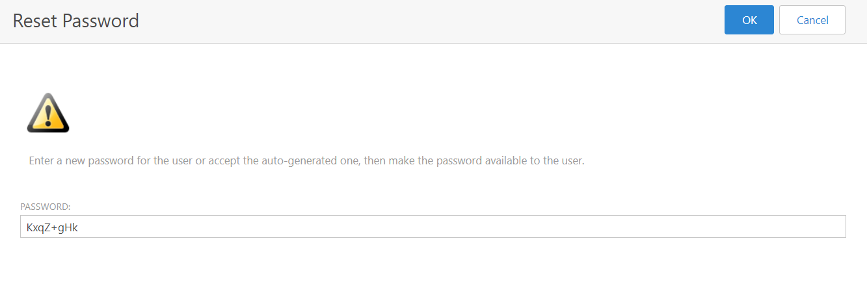
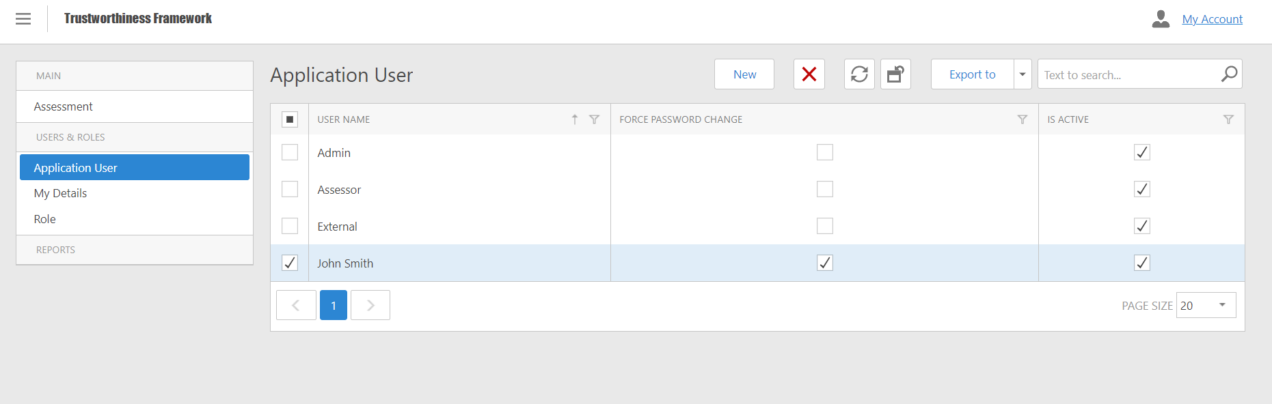
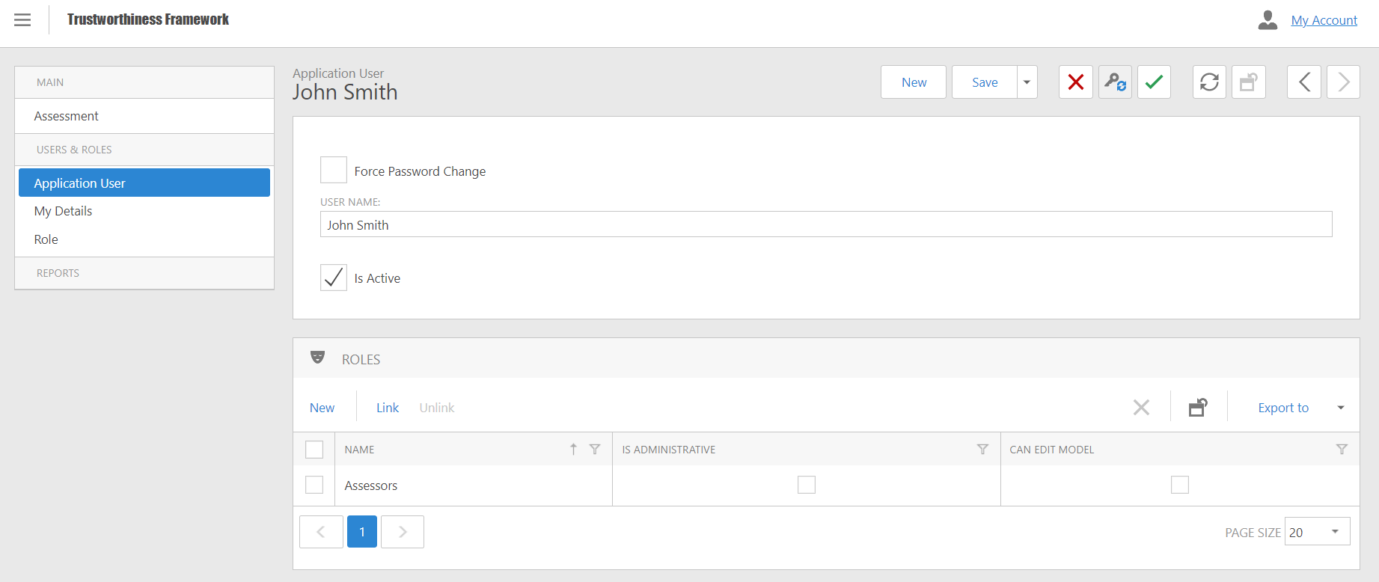
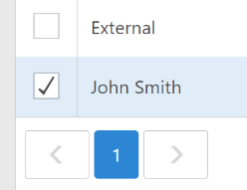
- Click the "Ok" button at the top right to confirm the operation and return to the user page.
- Click on the "Save" button, top right, to save the changes.
- The flag on the "Force Password Change" box confirms the success of the operation, and force the user to change the password at the first log-in.

Creating, searching and viewing an assessment
In order to view assessments, follow the steps:
- Select the "Assessment" page from the left menu.
- Search by entering your request in the "Search" box at the top right.
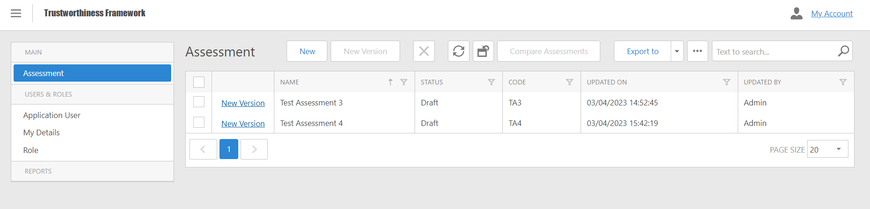
- Click on the name of the assessment to access the detail page.

In case the assessor needs to create a new assessment, there are two possibilities:
- By clicking the New button, a completely new assessment will be created, with all metrics having a zero score.
- By clicking the New Version link in the row of an existing assessment, it is possible to create a new version. That is, a new assessment which inherits the scores of the previous assessment, useful to assess a new version of the EIDS.

Editing an assessment
To speed up the assessment process, it is possible to automatically assign all metrics related to standards to which the system is already complaint. To do so, select the "Standard" tab by selecting the complaint box in the right column:
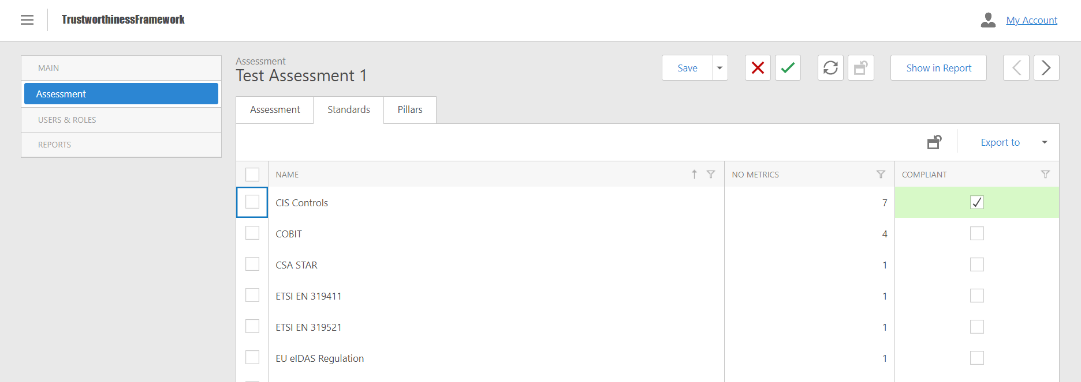
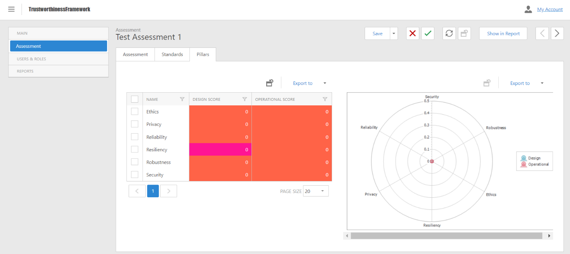
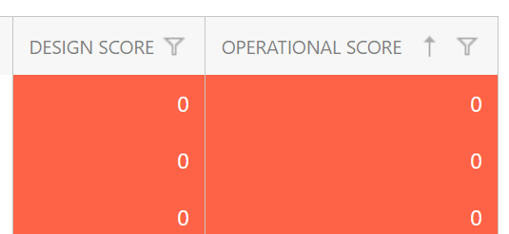
After having chosen the standards, it is possible to assess every specific pillar by selecting the Pillars tab and clicking on the row of the pillar to be modified.
The tab Pillar shows the design and operation scores, as well as the number of mechanisms.
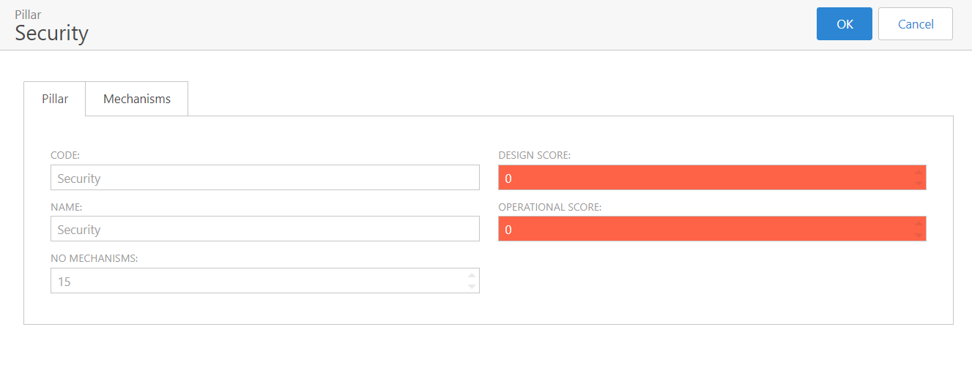

Clicking on the Mechanisms tab, it is possible to retrieve the list of underlying mechanism and the corresponding polar diagram.
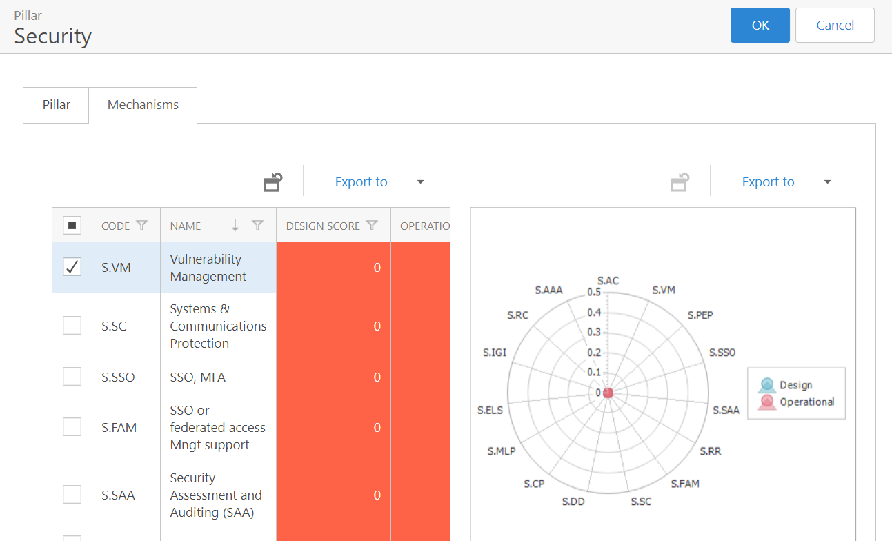
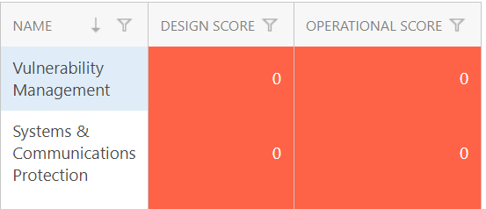

By clicking on a mechanism, a new web page will open showing the details of such entry. Tab Mechanism shows the associated scores, as well as the weights and metrics. Here, it is possible to check the Boolean field Exclude from Assessment to declare that such mechanism will not be assessed and shall be ignored during the scoring process.
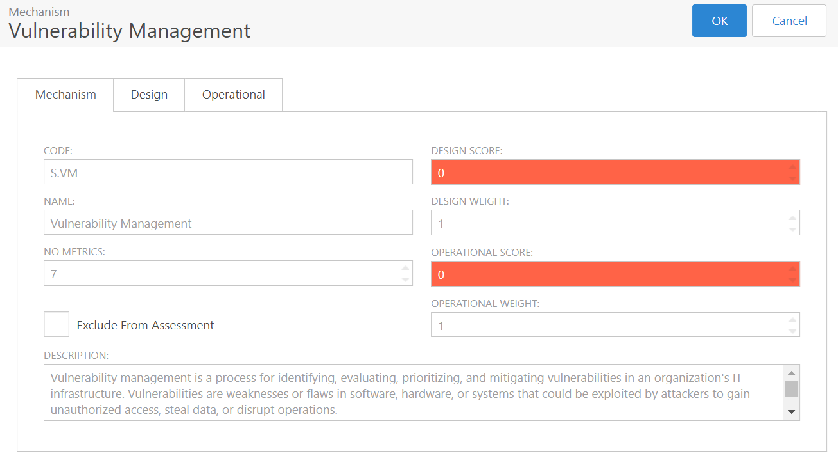

By selecting the Design and/or Operational tabs, the use can view all the corresponding metrics, of either Boolean (Y/N) or Percentage type. Using the pre-defined choices Selected Design/Operational Choice the assessor can select a common system configuration, quickly configuring the metric below. In addition, the assessor can also operate on each specific metric, by assigning a score to the columns Boolean Value and Percentage Value. To simplify the assignment, only one column is editable (with light blue background). Finally, clicking on the Info link, the user can view the description of such metrics as well as possible related standards.
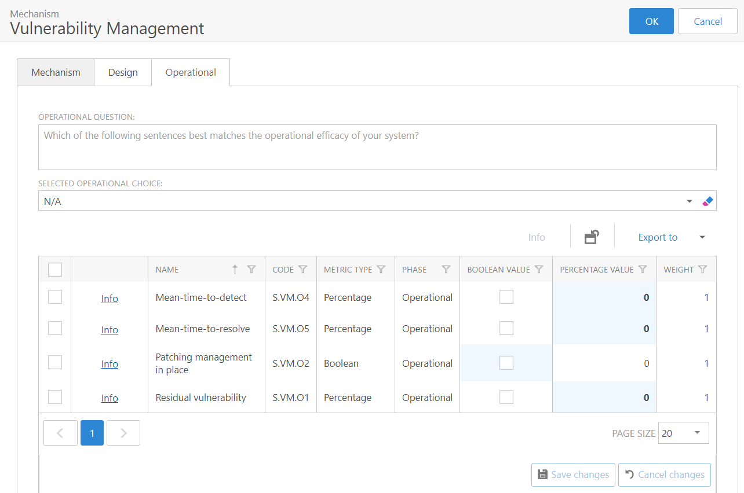

The user can recursively click OK or Cancel to confirm o cancel the changes, and to return to the previous level (mechanism and then pillar).
Note: Remember to save the assessment! However, if not properly saved, the tool will ask the user for confirmation before leaving the website.

Creating an assessment report
Assessments can be exported in a form of a report, following the steps:
- Select the assessment in the Assessment section by clicking on its row.
- In the detail page, click on the Show Report button.
- A new webpage will open, containing the report. It is possible to print it directly, or to extract it in various formats (PDF, XLS, Word…)
In the assessment report, all levels (pillar-mechanism-metric) of the assessment are shown, using the same background colours used in the tool (see Colour Legend section below).
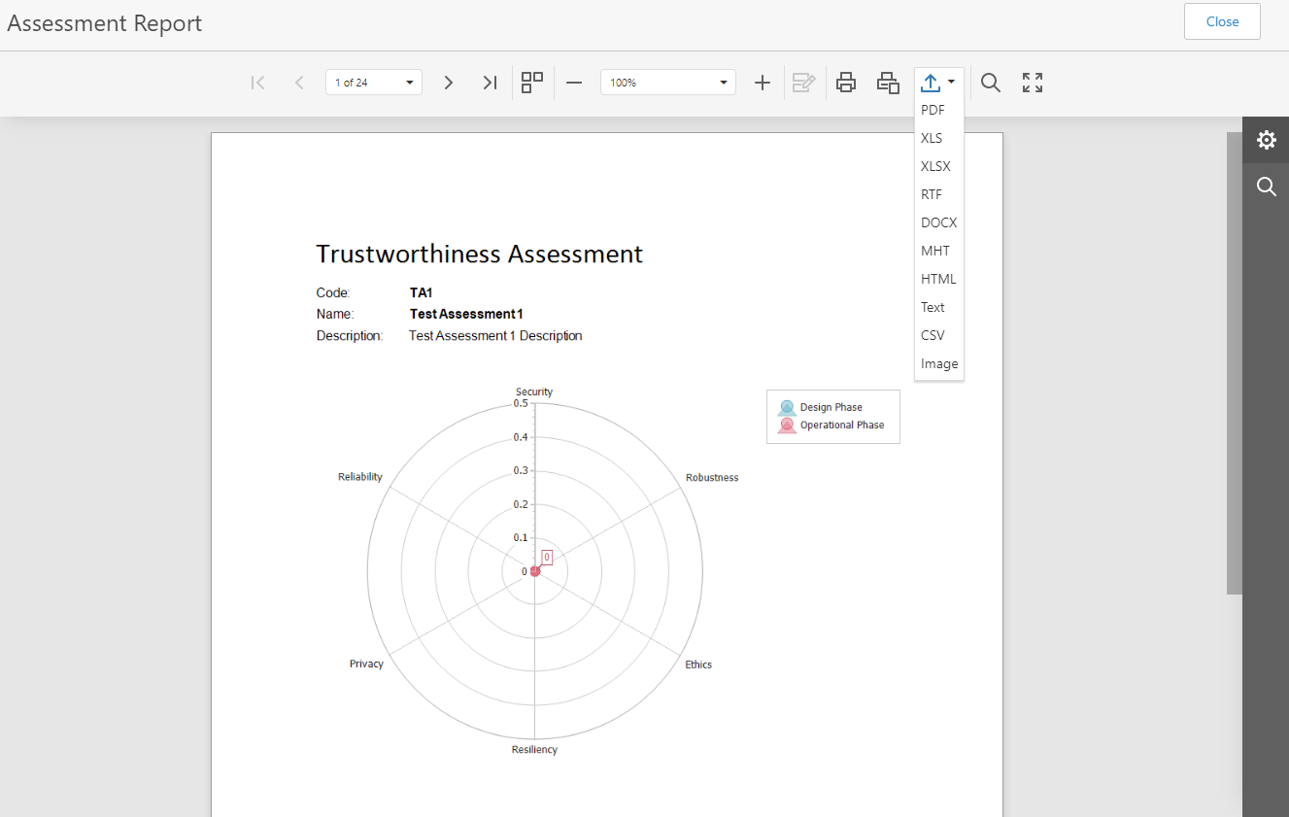
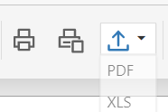

Creating a comparison report
Assessors (only) can generate a comparison report, between two existing assessments:
- Select two assessments in the Assessment section by clicking on the corresponding checkbox at the beginning of the row.
- When exactly two assessments are selected, the Compare Assessments button will be enabled. Clicking on the latter, will open a new webpage with the comparison report.
- As in the case of the assessment report, the comparison can be exported in various formats.
In the comparison report, the two assessments are compared side by side, at all levels (pillar-mechanism-metric). The corresponding scores are elicited with a yellow background in case they differ.
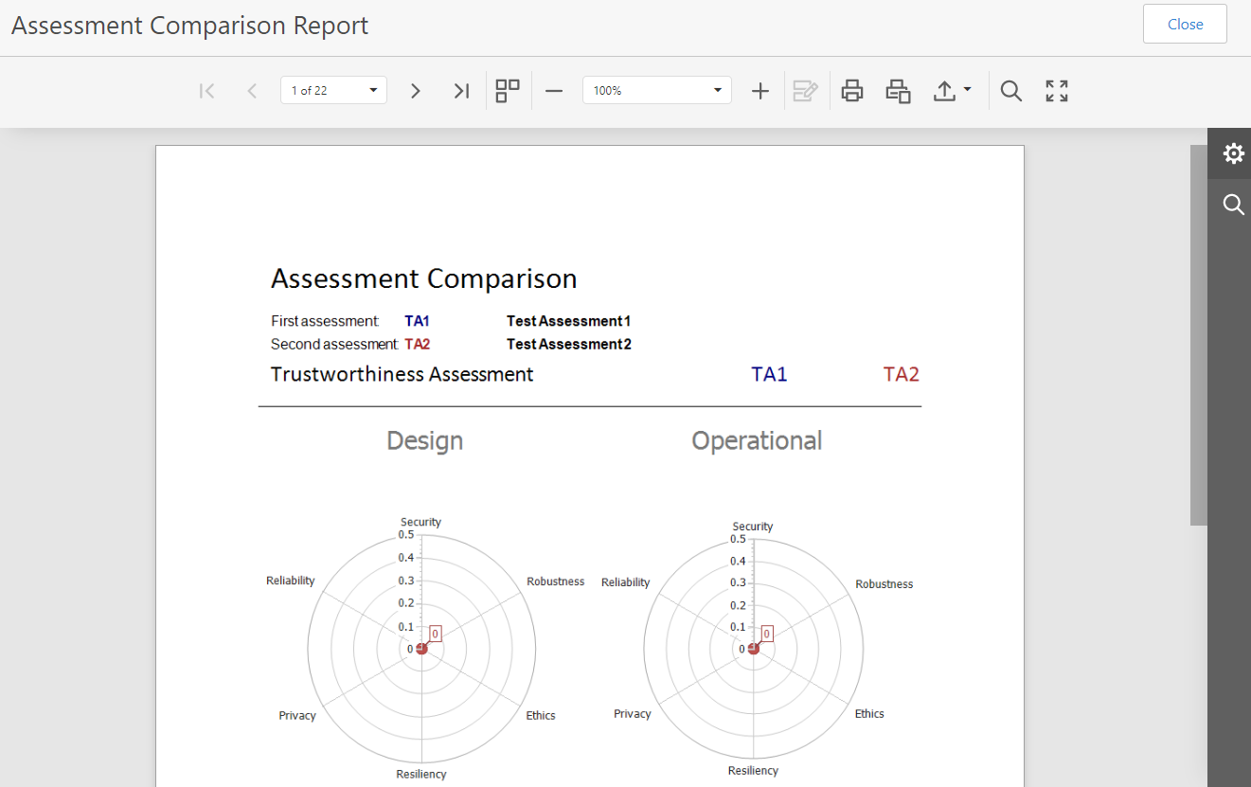

Colour legend
In the assessment web pages, and in the assessment report, background colours are used to give a quick representation of the design and operational score of a pillar, of a mechanism and of a metric. Below the legend of such colours:
Colour | Description
Deep PINK | When applied to a metric, it means such metric is mandatory and it forces a cap at the score of the corresponding mechanism and/or pillar. When applied to a mechanism or a pillar, it means that one ore more mandatory metrics are not satisfied.
TOMATO RED | When applied to a metric, a mechanism, and a pillar, it indicates that the corresponding score is <= 33%.
LEMON CHIFFON | When applied to a metric, a mechanism, and a pillar, it indicates that the corresponding score is between 33% and 66%.
LIGHT GREEN | When applied to a metric, a mechanism, and a pillar, it indicates that the corresponding score is > 66%.
TRANSPARENT | Used at mechanism level, indicates that such mechanism has been excluded from the assessment.

